|  |  |  |  |  |
| --- | --- | --- | --- | --- |
| **Experiment No. – 4** | | | | |
| **Date of Performance:** | 5/8/2025 | | | |
| **Date of Submission:** | 12/8/2025 | | | |
| Program Execution/  formation/  correction/  ethical practices  (06) | Timely  Submission  (01) | Viva  (03) | Experiment  Total (10) | Sign with Date |
|  |  |  |  |  |

**Experiment No. 4**

**Slicing, indexing, manipulating and cleaning with using fuzzy logic.**

**1.1 Aim:** Implement data slicing, indexing,manipulation, and cleaning using fuzzy logic.

**1.2 Course Outcome:** Understand the concept of Fuzzy Logic and application.

**1.3 Learning Objectives:** Implement a fuzzy controller system.

**1.4 Requirement:** Python (Google Colab)

**1.5 Related Theory:**

**Fuzzy Logic**

The term fuzzy refers to things that are not clear or are vague. In the real world many

times we encounter a situation when we can’t determine whether the state is true or false, their fuzzy logic provides very valuable flexibility for reasoning. In this way, we can consider the inaccuracies and uncertainties of any situation.Fuzzy Logic is a form of many-valued logic in which the truth values of variables may be any real number between 0 and 1, instead of just the traditional values of true or false. It is used to deal with imprecise or uncertain information and is a mathematical method for representing vagueness and uncertainty in decision-making.Fuzzy Logic is based on the idea that in many cases, the concept of true or false is too restrictive, and that there are many shades of gray in between. It allows for partial truths, where a statement can be partially true or false, rather than fully true or false.Fuzzy Logic is used in a wide range of applications, such as control systems, image processing, natural language processing, medical diagnosis, and artificial intelligence. The fundamental concept of Fuzzy Logic is the membership function, which defines the degree of membership of an input value to a certain set or category. The membership function is a mapping from an input value to a membership degree between 0 and 1, where 0 represents non-membership and 1 represents full membership. Fuzzy Logic is implemented using Fuzzy Rules, which are if-then statements that express the relationship between input variables and output variables in a fuzzy way. The output of a Fuzzy Logic system is a fuzzy set, which is a set of membership degrees for each possible output value. In summary, Fuzzy Logic is a mathematical method for representing vagueness and uncertainty in decision-making, it allows for partial truths, and it is used in a wide range of applications. It is based on the concept of membership function and the implementation is done using Fuzzy rules. In the boolean system truth value, 1.0 represents the absolute truth value and 0.0 represents the absolute false value. But in the fuzzy system, there is no logic for the absolute truth and absolute false value. But in fuzzy logic, there is an intermediate value to present which is partially true and partially false.

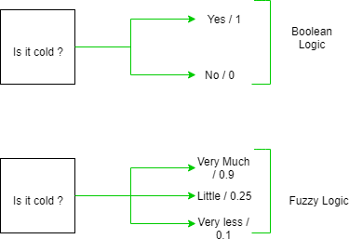

**Fuzzy Membership Functions.**

We already know that fuzzy logic is not logic that is fuzzy but logic that is used

to describe fuzziness.This fuzziness is best characterized by its membership

function.

That membership function represents the degree of truth in fuzzy logic.

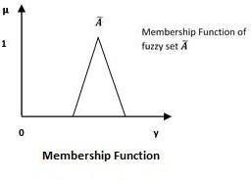

Following are a few important points relating to the membership function –

* Membership functions were first introduced in 1965 by Lofti A. Zadeh in his first research paper “fuzzy sets”.
* Membership functions characterize fuzziness (i.e., all the information in a fuzzy set), whether the elements in fuzzy sets are discrete or continuous.
* Membership functions can be defined as a technique to solve practical problems by experience rather than knowledge.
* Membership functions are represented by graphical forms.
* Rules for defining fuzziness are fuzzy too.

## **Mathematical Notation**

We have already studied that a fuzzy set *Ã* in the universe of information *U* can be defined as a set of ordered pairs and it can be represented mathematically as –

A˜={(y,μA˜(y))|y∈U}

Here μA˜(∙)=membership function of A˜; this assumes values in the range from 0 to 1, i.e., μA˜(∙)∈[0,1].

The membership function μA˜(∙) maps U to the membership space M.

The dot (∙) in the membership function described above, represents the element in a fuzzy set; whether it is discrete or continuous.

## **Features of Membership Functions**

The different features of Membership Functions.

## **Core**

For any fuzzy set A˜, the core of a membership function is that region of the universe that is characterized by full membership in the set. Hence, core consists of all those elements y of the universe of information such that,

μA˜(y)=1

## **Support**

For any fuzzy set A˜, the support of a membership function is the region of the universe that is characterized by a nonzero membership in the set. Hence core consists of all those elements y of the universe of information such that,

μA˜(y)>0

## **Boundary**

For any fuzzy set A˜, the boundary of a membership function is the region of the universe that is characterized by a nonzero but incomplete membership in the set. Hence, core consists of all those elements y of the universe of information such that,

1>μA˜(y)>0

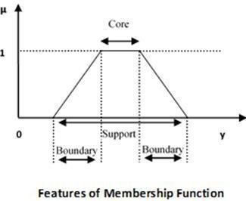

## **Properties of Fuzzy Sets:**

Fuzzy sets can be considered as an extension and gross oversimplification of classical sets. It can be best understood in the context of set membership. Basically it allows partial membership which means that it contains elements that have varying degrees of membership in the set. From this, we can understand the difference between classical sets and fuzzy sets. Classical set contains elements that satisfy precise properties of membership while fuzzy set contains elements that satisfy imprecise properties of membership.

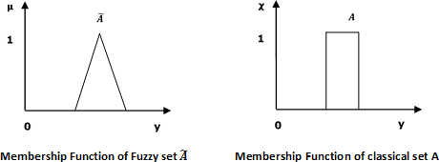

## **Mathematical Concept**

A fuzzy set A˜ in the universe of information U can be defined as a set of ordered pairs and it can be represented mathematically as –

A˜={(y,μA˜(y))|y∈U}

Here μA −(y)= degree of membership of y in \widetilde{A}, assumes values in the range from 0 to 1, i.e., μA˜(y)∈[0,1].

## **Representation of fuzzy set**

Let us now consider two cases of the universe of information and understand how a fuzzy set can be represented.

## **Case 1:**When universe of information U is discrete and finite – A˜={μA˜(y1)y1+μA˜(y2)y2+μA˜(y3)y3+...}

={Σni=1μA˜(yi)/yi}

## **Case 2:**When universe of information U is continuous and infinite − A˜={∫μA˜(y)y}

In the above representation, the summation symbol represents the collection of each element.

## **Operations on Fuzzy Sets**

Having two fuzzy sets A˜ and B˜, the universe of information U and an element 𝑦 of the universe, the following relations express the union, intersection and complement operation on fuzzy sets.

## **Union/Fuzzy ‘OR’**

Let us consider the following representation to understand how the **Union/Fuzzy ‘OR’** relation works −

μA˜𝖴B˜(y)=μA˜∨μB˜∀y∈U

Here ∨ represents the ‘max’ operation.

## **Intersection/Fuzzy ‘AND’**

Let us consider the following representation to understand how the **Intersection/Fuzzy ‘AND’**

relation works −

μA˜∩B˜(y)=μA˜𝖠μB˜∀y∈U

Here 𝖠 represents the ‘min’ operation.

**Complement/Fuzzy ‘NOT’**

Let us consider the following representation to understand how the **Complement/Fuzzy ‘NOT’**

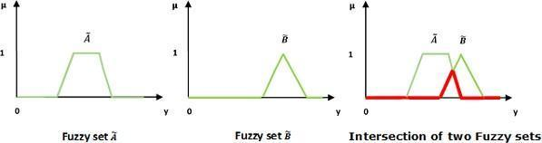

**1.6 Procedure:**

We have to perform different fuzzy logic operations and fuzzy sets on a given data set.

Then perform data visualization on the dataset.

**1.7 Output:**

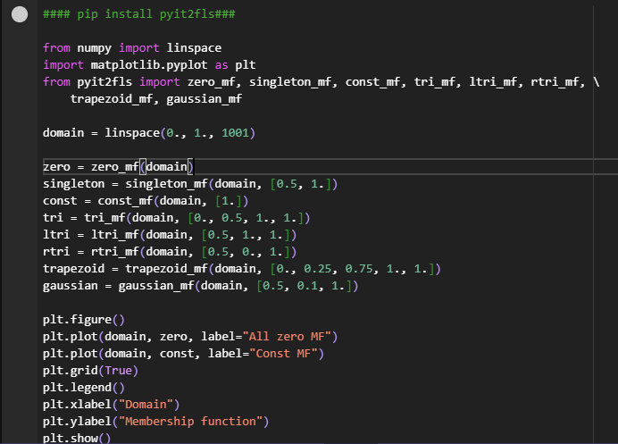

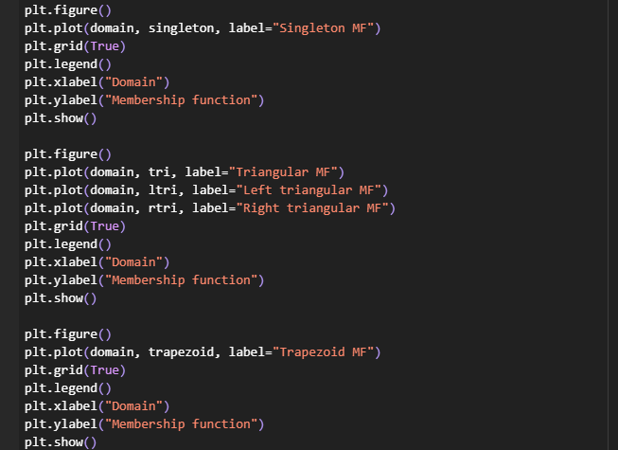

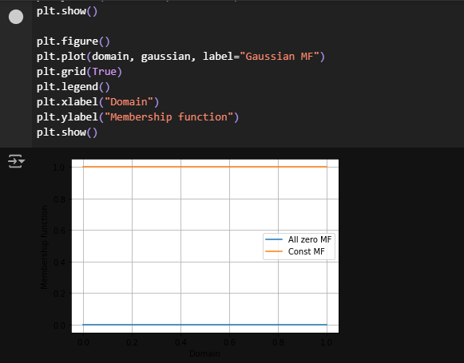

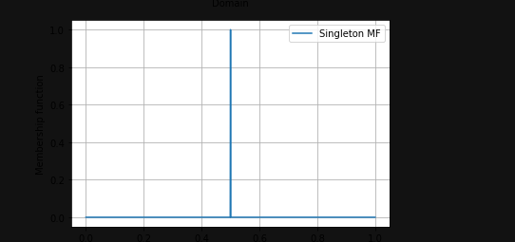

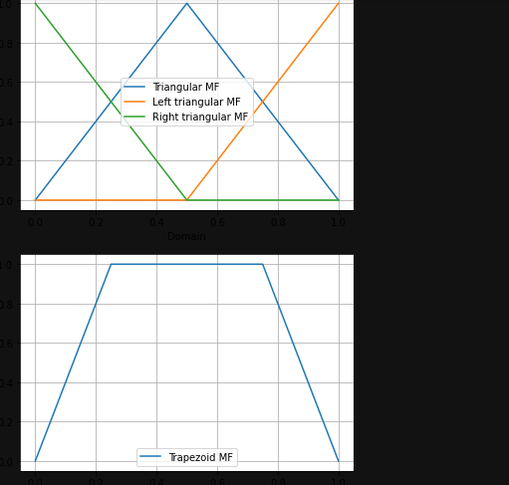

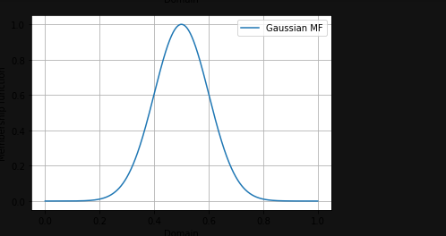

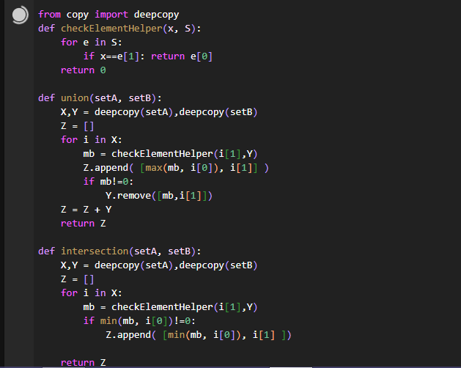

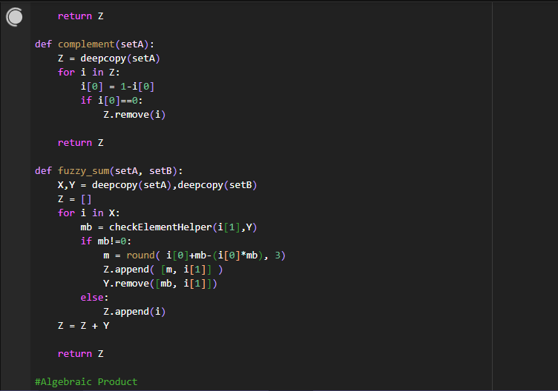

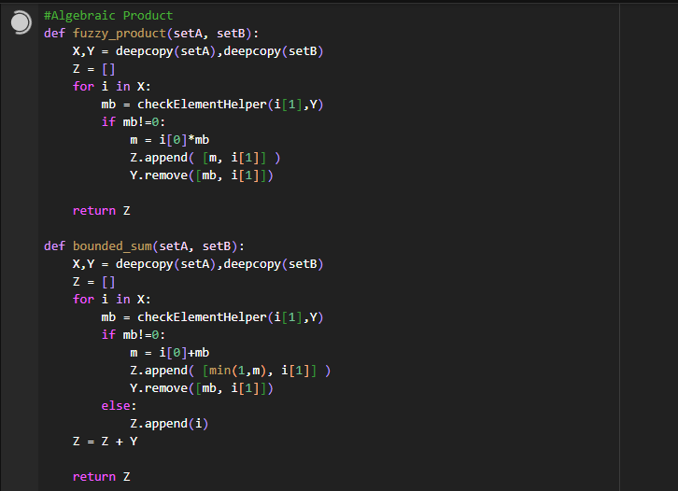

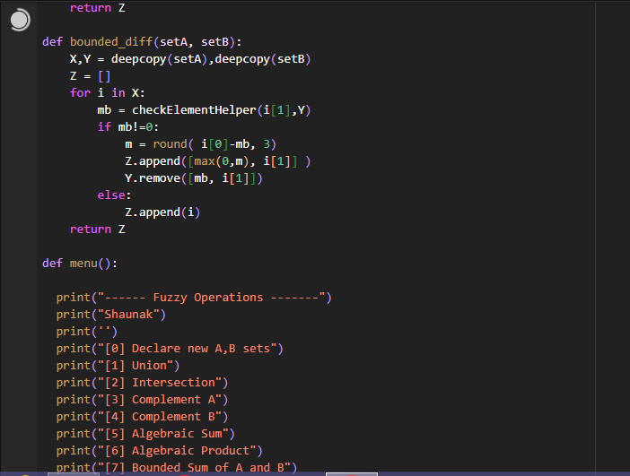

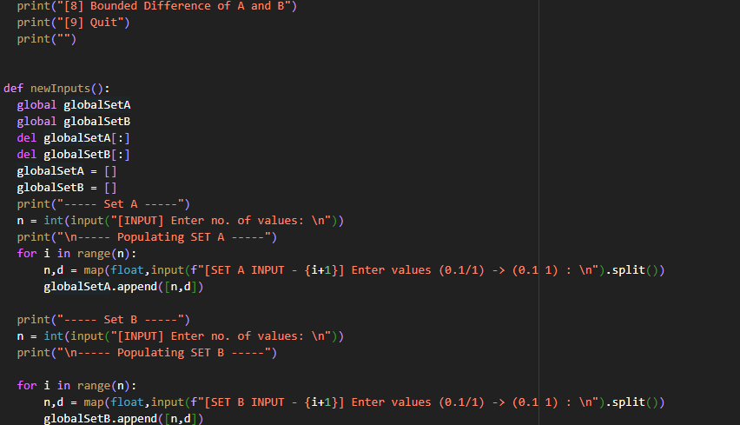

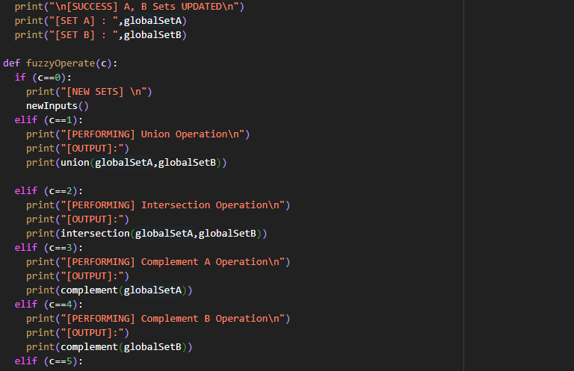

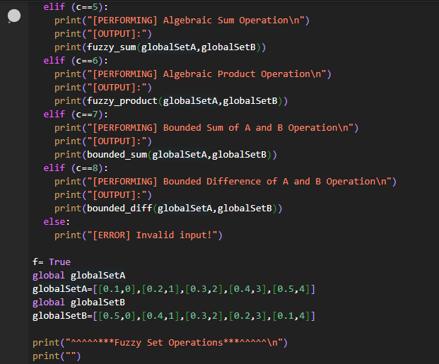

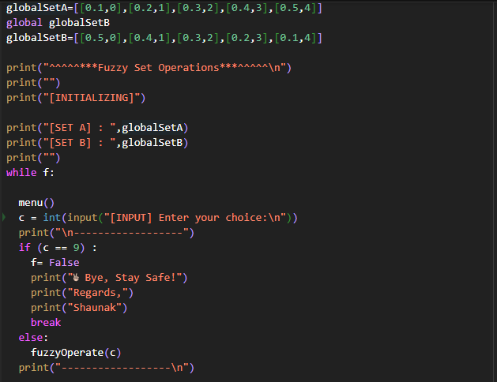

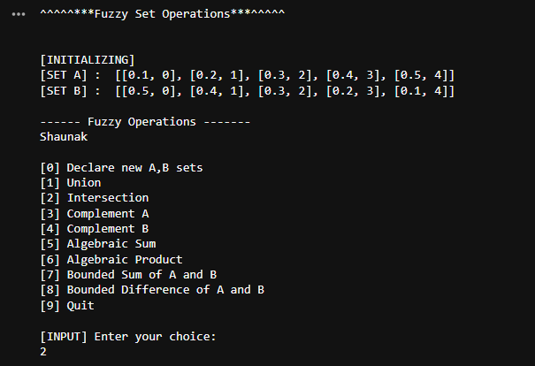

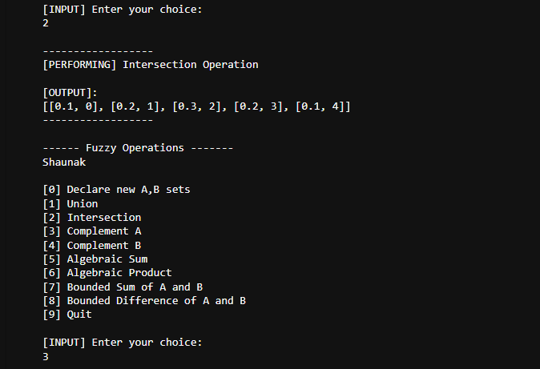

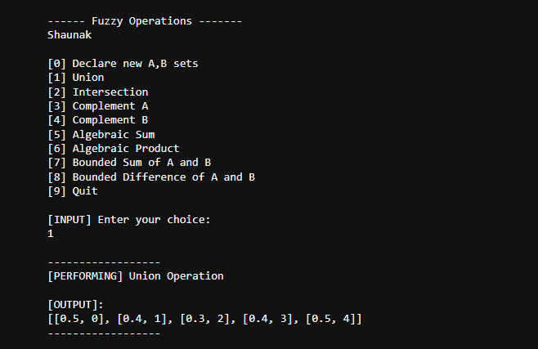

**1.8 Conclusion:**

In this experiment, we applied fuzzy logic techniques to clean, slice, index, and manipulate a dataset. Fuzzy logic allowed us to handle missing and noisy data by applying fuzzy rules that mimic human reasoning. We demonstrated how fuzzy logic can effectively clean and manipulate datasets, making it a valuable tool in data preprocessing and analysis, particularly when dealing with imprecise or uncertain data.

**1.9 Questions:**

1.What is the Fuzzy Logic?

Ans: **Fuzzy logic** is a mathematical framework that deals with reasoning and decision-making under uncertainty, allowing for degrees of truth rather than a strict true/false dichotomy. Unlike traditional binary logic, fuzzy logic can represent values between 0 and 1, enabling a more nuanced understanding of concepts that are not precisely defined (e.g., "hot" or "tall").

**Key Features:**

* **Degrees of Truth:** Values range between 0 and 1, representing varying levels of truth.
* **Fuzzy Sets:** Elements have different degrees of membership in a set (e.g., "tall people").
* **Linguistic Variables:** Uses terms like "low," "medium," and "high" to describe values.
* **Rules and Inference:** Employs if-then rules to derive conclusions from fuzzy inputs.

**Applications:**

Fuzzy logic is commonly used in control systems (like washing machines and air conditioners), artificial intelligence, and expert systems to improve decision-making in uncertain environments.

2.Explain the Different operation on fuzzy logic.  
Ans:

**1. Union (OR):** Combines two fuzzy sets by taking the maximum membership value at each element.

μA∪B(x) = max ( μA(x), μB(x))

**2. Intersection (AND):** Combines two fuzzy sets by taking the minimum membership value at each element.

μA∩B(x) = min ( μA(x), μB(x))

**3. Complement (NOT):** Inverts the membership values of a fuzzy set.

μ¬A(x) = 1 − μA(x)

**4. Algebraic Sum:** Combines membership values by adding them while ensuring the result is within [0, 1].

μA+B(x) = μA(x) + μB(x) − μA(x) ⋅ μB(x)

**5. Algebraic Product:** Combines membership values by multiplying them.

μA×B(x) = μA(x) ⋅ μB(x)

**6. Cartesian Product:** Creates a fuzzy relation by combining elements from two fuzzy sets.

R(x,y) = min ( μA(x) ,μB(y))

**7. Bounded Sum:** Limits the addition of two fuzzy sets to a maximum of 1.

μA⊕B(x) = min( 1, μA(x) + μB(x))

**8. Bounded Difference:** Calculates the difference between two fuzzy sets while ensuring the result is not negative.

μA⊖B(x) = max( 0, μA(x) − μB(x))